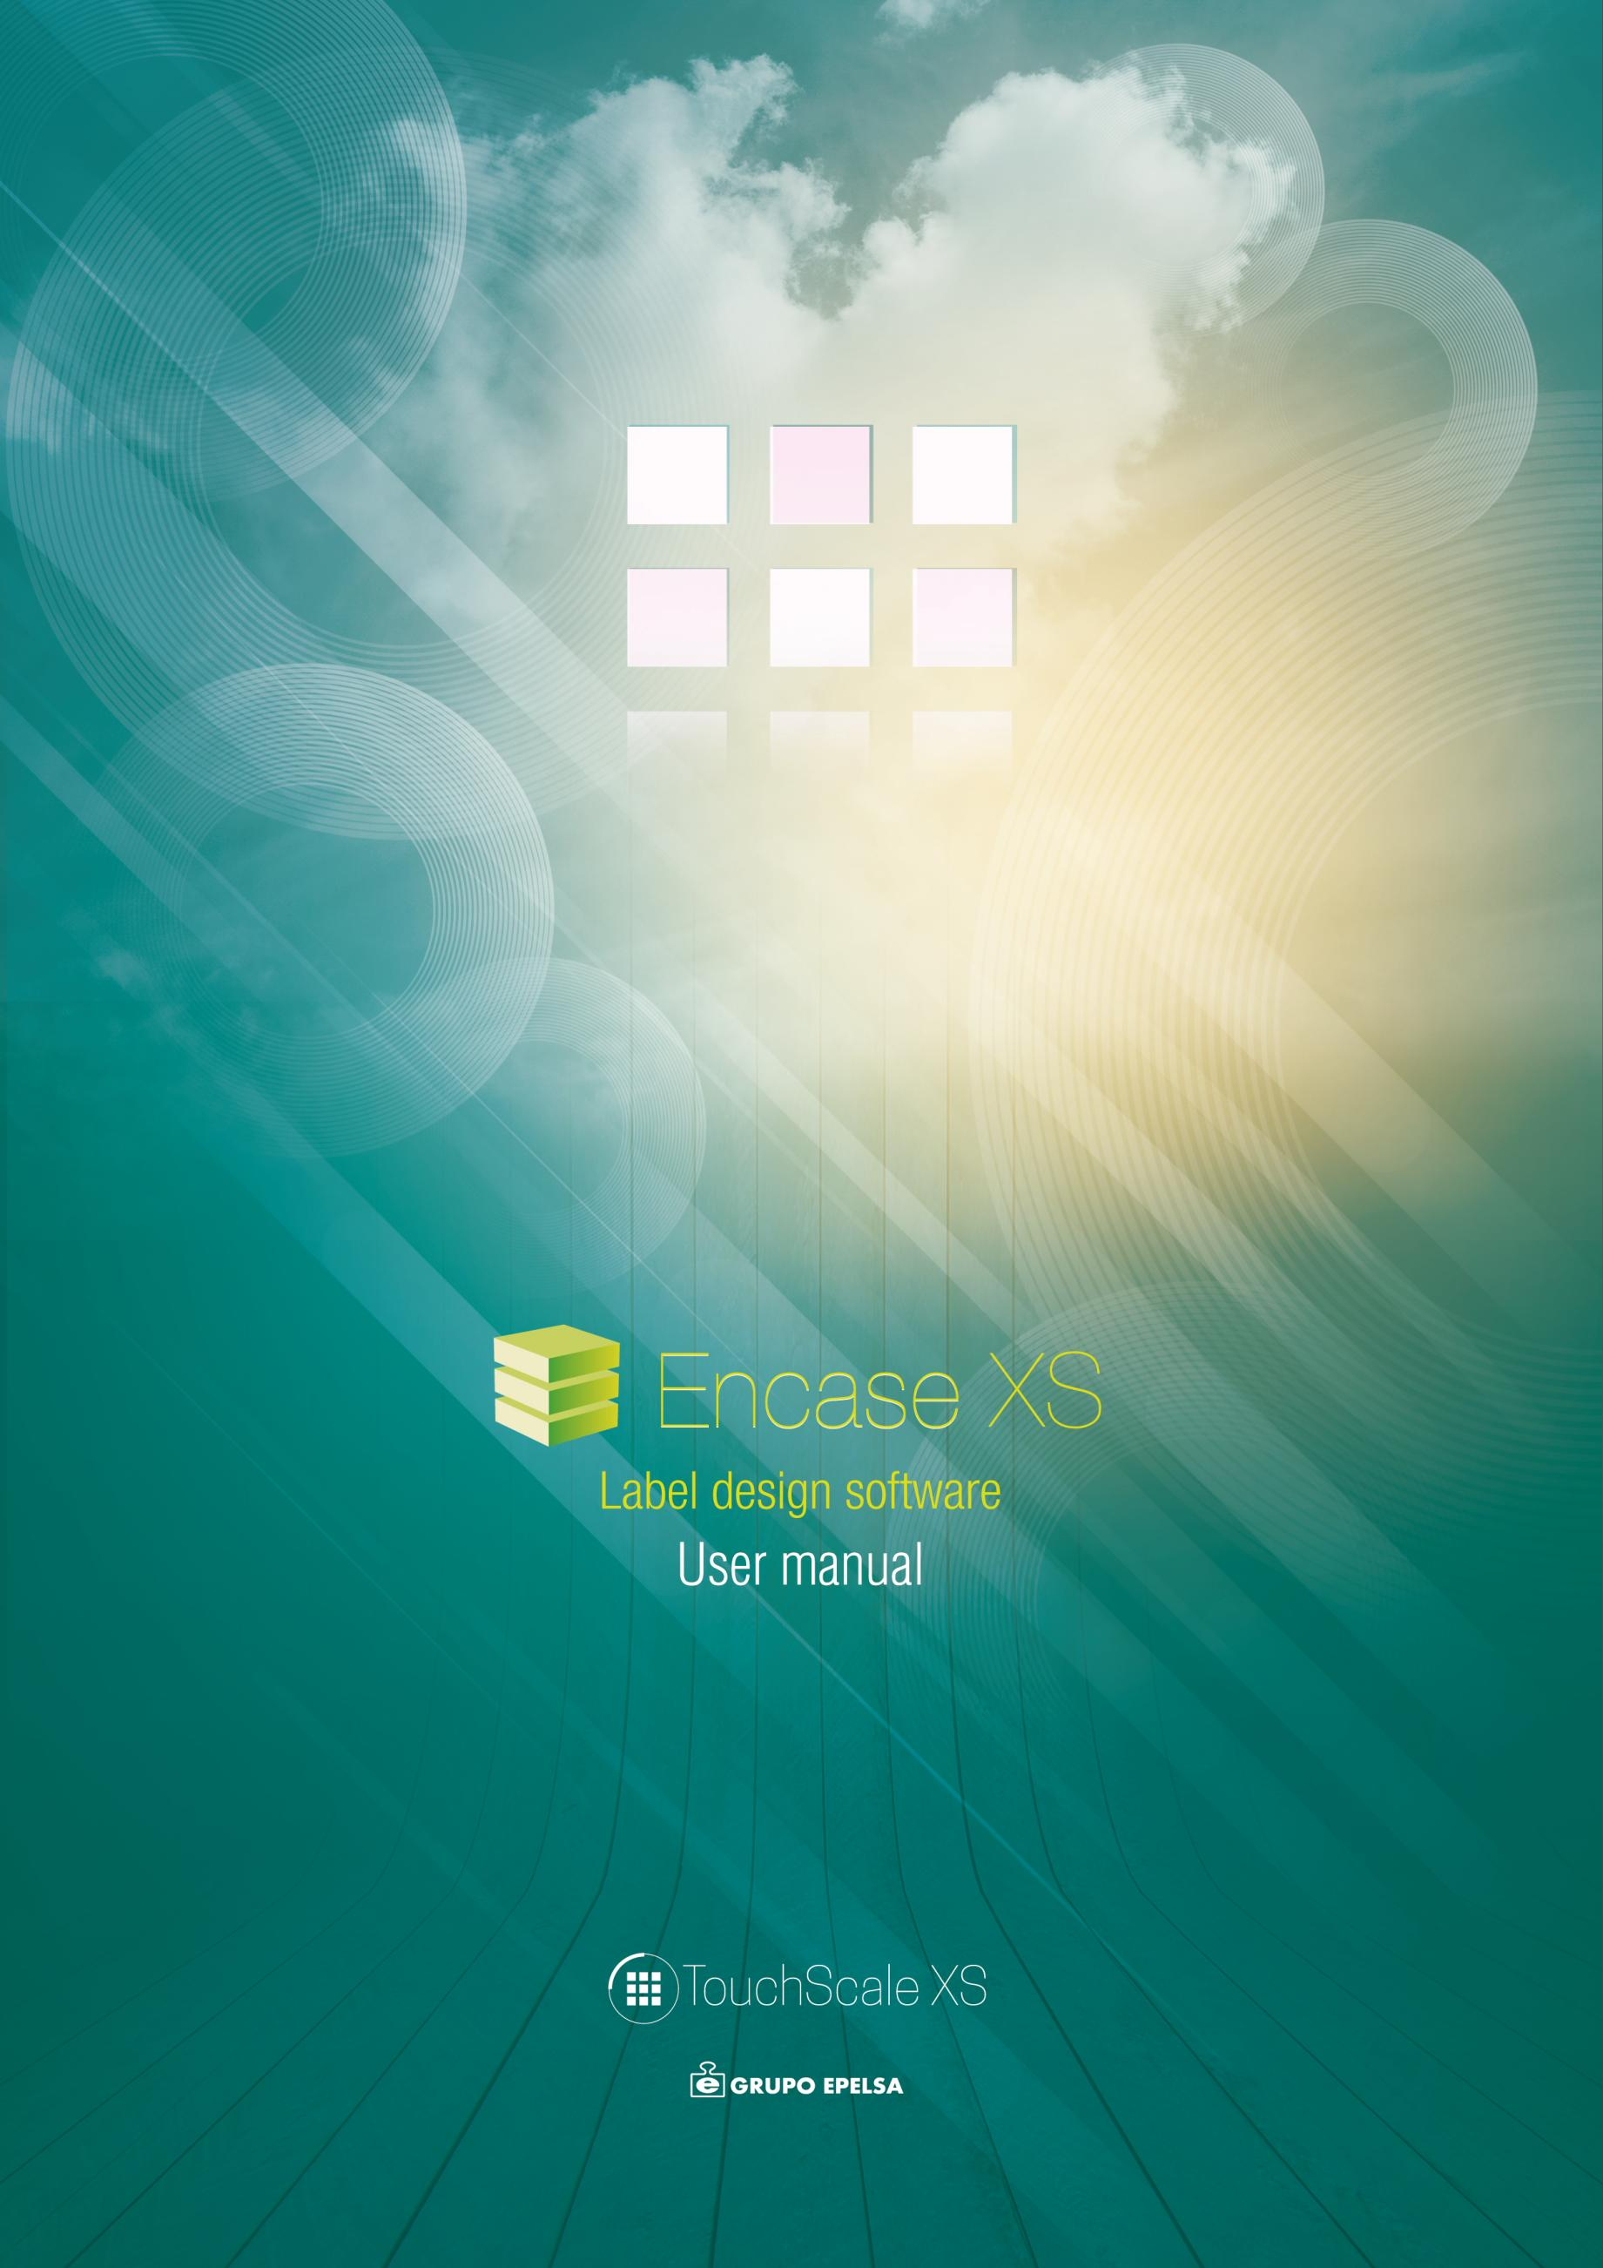

Index
INTRODUCTION 3
INTERFACE 3
Properties window 4
Drawing window 4
New label window 5
Label elements 5
DESIGN NEW LABELS 5
ADD CONDITIONS 7
SELECT ADDED ITEMS 7
ELEMENTS 8
Text 8
Fields 8
ID Values FOR EACH FIELD 9
HEADERS SELECTION 9
Pictures 10
Seals 10
Barcodes 10
EXAMPLES 10
LABEL LOADING 11

INTRODUCTION
The Encase_XS program is an additional tool for the XS scale for the design labels in XML format.

INTERFACE
Drawing space
Add/remove design
Elements list
File tools
Properties window
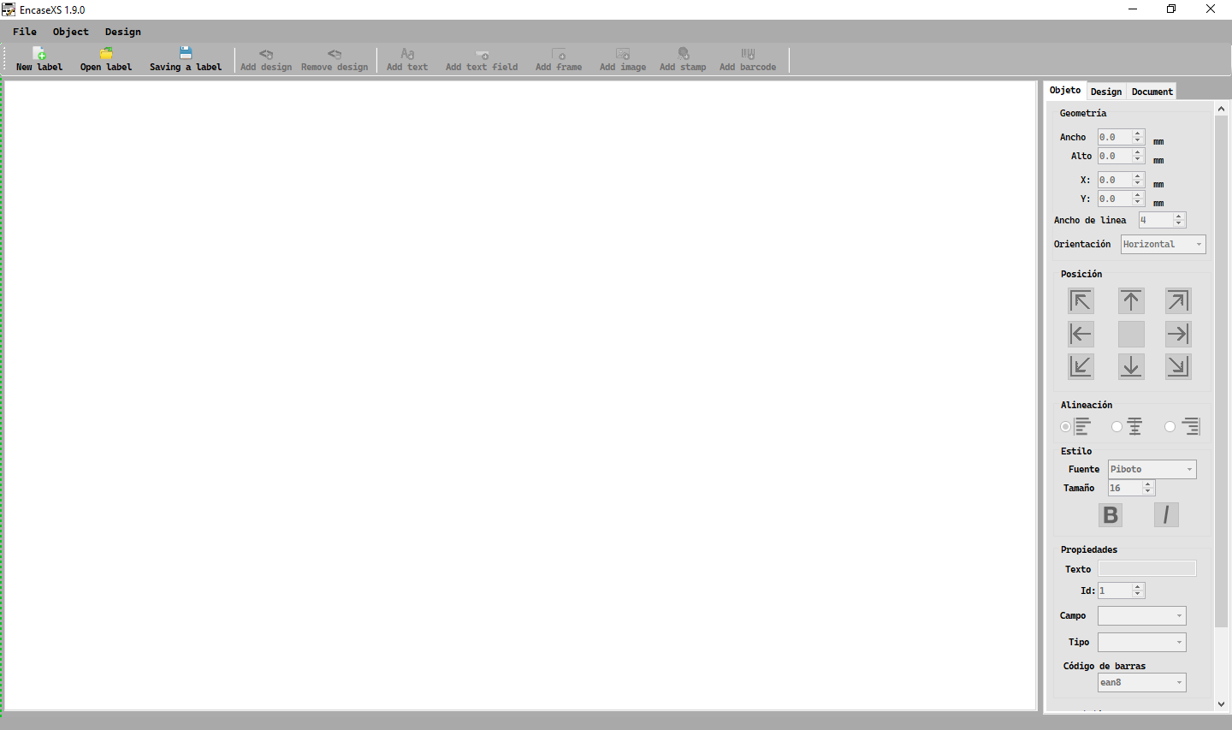

Peso neto

Properties window
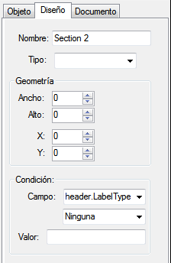
Design name
Object
properties
Design properties
Dimensiones del objeto
Section type
Design size
Object dimensions
Document properties
Posición del objeto
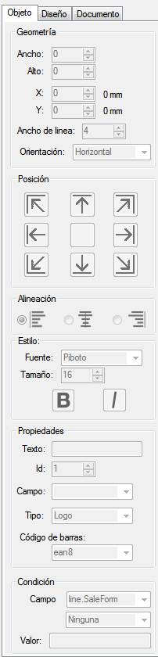
Design position
Box line width
Field to be evaluated

Object position
Object orientation
Value to compare with

Condition

Object position

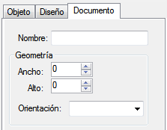
Label name
Alignment
Font family
Label size
Bold
Italic
Object ID
Font size
Label orientation
Object text
Picture type
Field
Barcode type
Field to be evaluated

Condition
Value to compare with

Drawing window
Label drawing
Design list
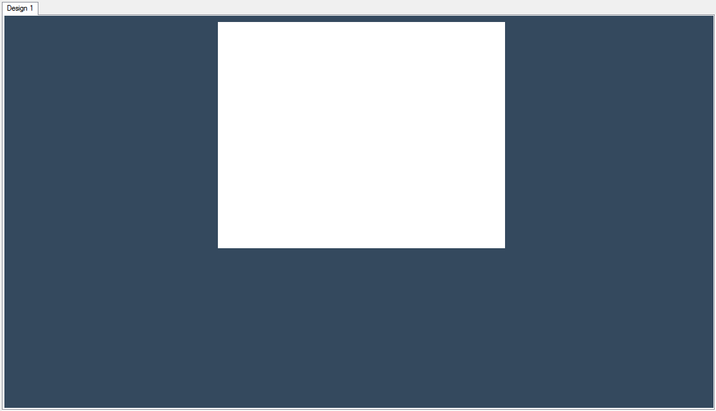

New label window
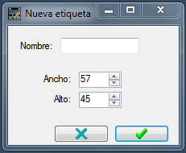
Label name
Label size

Accept

Cancel

Label elements
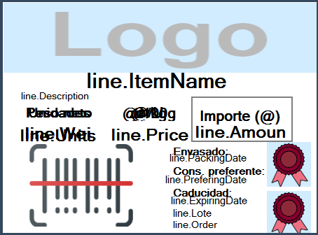
Variable fields
Box
@ = Currency symbol
Fixed text

Seals

Barcode

DESIGN NEW LABELS

When starting the application the options are locked and the canvas is empty.
To create a new label follow the steps below:
- Click on the button to create a new label.

- Then enter the name of the label and its dimensions.
Enter the name of the label
Enter the dimensions of the label

Accept

- Once the data has been entered, the buttons will be unlocked and the drawing window will show a representation of the label, to which the objects will be added.
Place the fields on the label
- To create the elements of the label we will use the buttons on the toolbar. The elements will be created at the coordinates (0,0), to place them in the desired position just drag them to the desired coordinates.
To delete unwanted items, simply select them and click on the Delete key or right-click on the mouse. The elements can be moved either by using the up, down, left and right keys, or by dragging the element with the mouse.
In order for the currency symbol to be painted on the fixed texts, this is indicated by an @. When processing the label and detecting this character, the scale will replace it with the configured currency symbol.
- To create two different styles for the same label, simply click on create a new design. To delete it, click on the delete layout button.
Currently there are 2 layouts implemented:
Weighing: Design to be used when printing the label for the weighing of an item.
Totals: Design of the label that is printed after a certain number of lines and that summarises the batch or the set of weighs carried out.
To select the type of design, in the design properties tab, select the type of design in the corresponding drop-down menu.
Select the type of design
- To set the properties of each element, simply select the element and use the properties window to customise the element.

ADD CONDITIONS
Conditions can be added to both label fields and layouts so that elements can be painted or not depending on certain parameters.
To add conditions:
- Select the desired item.
- Go to properties window (object window if it is a field of the label, or layout window if it is the full style of the label).
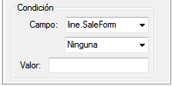

- Set the condition for that element to be painted.
Select the condition
Select the field to be evaluated
Set the value to be compared to

SELECT ADDED ITEMS
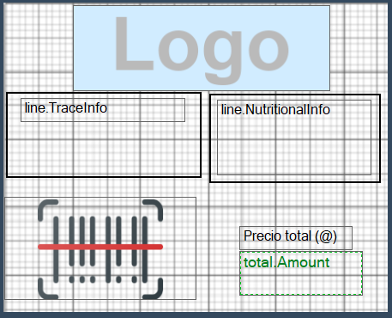
When you have one or more elements on the design sheet, to select an element, just double click on it. We will know that it is selected because the text inside it and the border turns green. Once the object is selected, we can change its position by dragging it with the mouse or modify its size in the properties window. To delete it, press the "Delete" key.

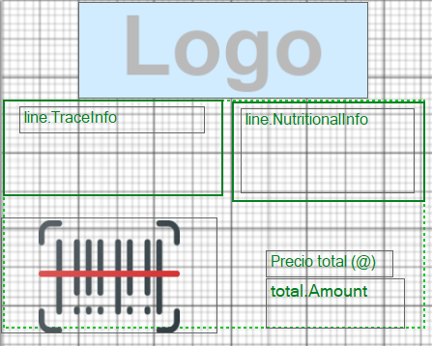
Sometimes we may want to make a multiple selection. It’s usefull to move or delete a group of objects in one move. To make a multiple selection just hold down the “Control”key and double-click on the objects you want to select.
IMPORTANT: In many cases we will find objects that are covering other objects. To select an object that is “behind” another just double click on it until you have selected the object you want to modify.

ELEMENTS
The elements drawn on the label are indicative in terms of font size and font family.
If some of the objects drawn on the label are not used in XS, they will simply not be printed. On the other hand, if you have some elements configured in XS that are not drawn on the label, they will be ignored. The elements placed on the label are "gaps" that XS can use or not, depending on how they are configured.

Text
These are fixed texts that are printed as defined. The only parameter that is replaced is the @, which will be replaced by the currency symbol defined in the balance.

Fields
These are texts that will show values related to the sale or to the product that has been sold/packaged.
line.SaleForm | Type of sale (0 for sale per unit, 1 for sale per 100g, 2 for sale per kilogram)
line.ItemName | Article name
line.Description | Long text of the article
line.Units | Units sold
line.Weight | Weight of the sale
line.Price | Price of the article
line.NutritionalInfo | Información nutricional del artículo
line.TraceInfo | Información de trazabilidad
line.Off.Description | Description of the discount applied
line.Off.Import | Discounted import
line.Amount | Total amount of the sale
line.PackagingDate | Packaging date
line.PreferingDate | Best-before date
line.ExpiringDate | Expiry date
line.Lote | Batch number
line.Order | Order number
header.Text | Predefined free texts on the scale
total.Weight | Total packaged weight
total.Units | Total units packaged
total.Amount | Total amount packaged
total.Operations | Number of operations

Several fields can be assigned the same and showing different values / texts. To do this, simply assign the ID number in the properties panel. The ID number corresponds to the text number or value that is set in XS.

ID Values FOR EACH FIELD
The following fields are affected by the ID assigned to them as indicated below.
Field | Addmited ID’s | Description
line.Description | 1, 2 | Indicates which “Long Text” are going to be displayed
header.Text | 1-5 | Indicates which header number is to be displayed depending on the type of header selected (department or scale) which has to be selected in the scale. (See next section)
header.Seal | 1-7 | Indicates the Seal number to be displayed
header.Logo | 1 | It only admits the 1 Value to display the picture Selected in the Scale
To the others fields the ID assignated its not relevant.

HEADERS SELECTION
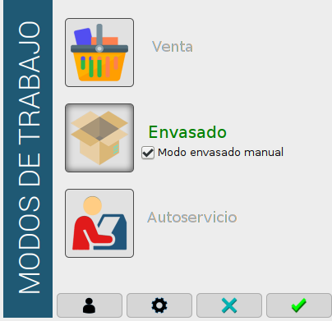
To select the type of header you want to display, go to the TouchScaleXS work mode configuration:
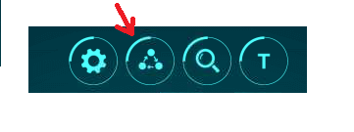

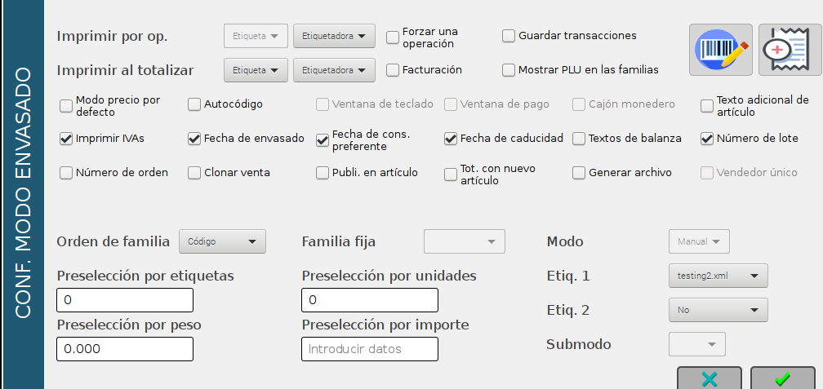
If you select “scale texts”, the scale headers will be displayed and if its left unselected, the department texts will be displayed instead.

Pictures
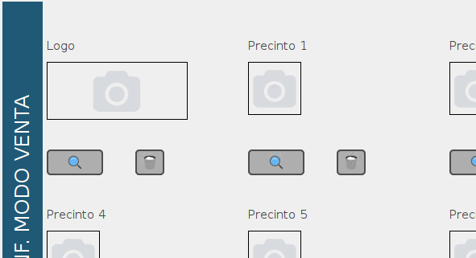
Place where the logo defined in the XS program will be printed in the configuration menu of the work mode.

Seals
Location where the Stamps/precincts configured in XS will be printed.
The id property sets the corresponding seal number.
Número de Id

Barcodes
Location where the barcode generated on the basis of the scale configuration will be printed.

EXAMPLES
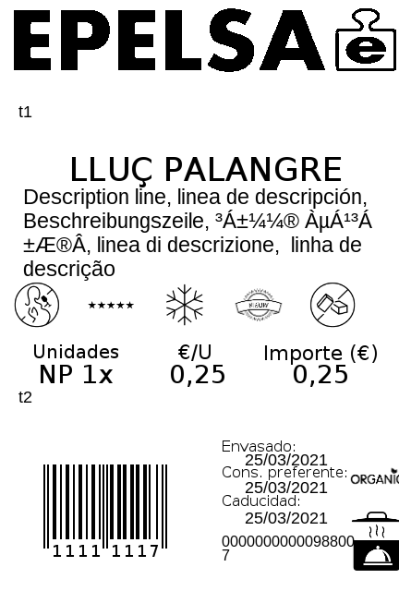
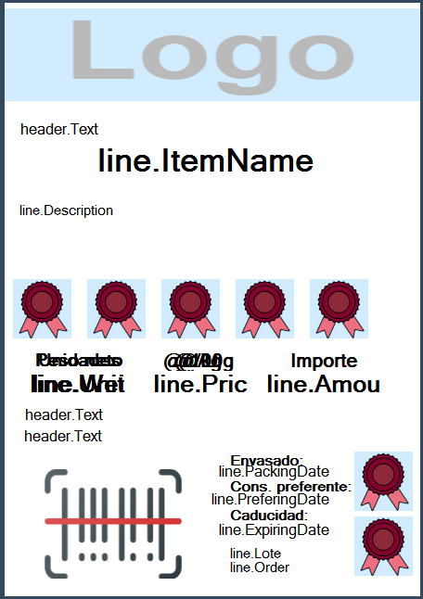

LABEL LOADING

Once the label structure has been defined, it must be loaded into the scale and selected in the XS for use.
To do this, the xml file of the label is copied to the xml folder of the scale using the file explorer.

- Open the file explorer
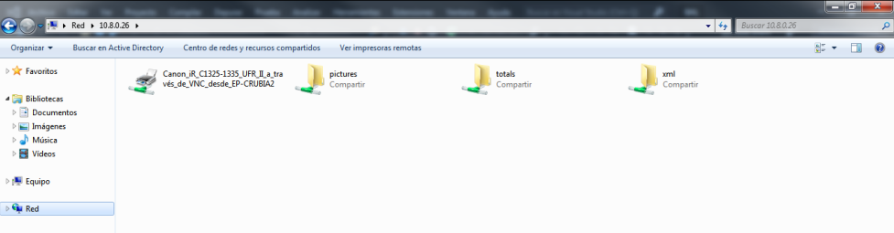
- Type \\ip> (where <ip> is the ip address corresponding to the desired scale) in the address bar:

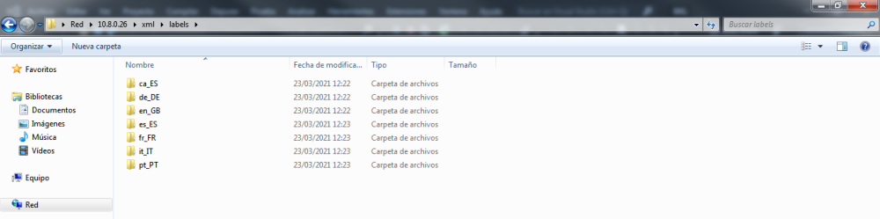
- Inside the xml folder, select the path labels -> <corresponding language> and copy the created xml file into this folder.

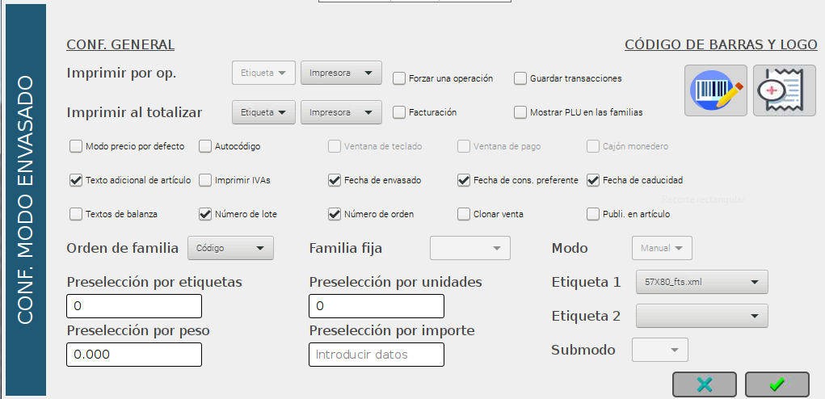
- Select the desired label in XS.

